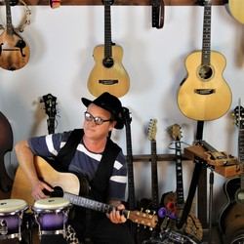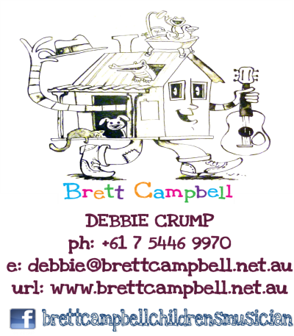Brett Campbell’s Children’s Music Show

is coming to

Goonellabah Preschool.

Brett Campbell is an Australian children's musician. Usually playing more than  
200 shows a year, Brett is a busy professional musician who has also released 6 albums in the last 10 years. He has performed at many of Australia's best festivals and has toured nationally with Hi-5, Peter Combe and Justine Clarke.

His extensive songbook, musical and theatrical experience and multiple instrumental capabilities enable Brett to perform a show full of singing, dancing and games.    
Children have the opportunity to get involved in the show and see an experienced musician playing great fun, quirky songs.

When: Wednesday 7th June Time: 9.30am Cost: $8 per child.

Parents are invited to attend.

Brett Campbell Children’s Music Show Permission Note

Please return consent form and payment by 9am on Wednesday 7th June.

I consent to my child or children___________________________________

participating in the Brett Campbell Children’s Music Show at Goonellabah Preschool On Wednesday 7th June 2017.

I enclose $8 per child as payment for the show.

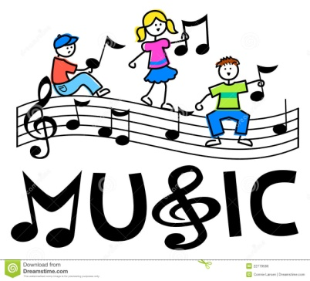Parent Carer: Name ____________________ Signature____________________